ELCT 201 – EE Laboratory

Project Zero: Instrument Skills

Carson Murray

9/7/2022

Department of Electrical Engineering

University of South Carolina

Columbia, SC 29208

# Abstract

A set of exercises taught basic use of the oscilloscope, function generator, and digital multimeter. The oscilloscope trigger controls were found to be especially important for capturing the interesting parts of a voltage waveform, while the voltage and time (vertical and horizontal) controls were important for displaying the interesting features at a size that was appropriate to see and measure. The function generator could produce several different waveforms including sine, triangle, and pulse, with user-selected properties such as frequency and amplitude, and also several option parameters such as duty, and dc offset. Importantly, the function generator was not an ideal voltage source, but instead had a 50 Ω output resistance. The digital multimeter turned out to be a good tool for quickly measuring the rms value of a signal, or the dc offset of a signal.

# Introduction

A resistive voltage divider, as shown in Figure 1 served as the circuit foil for learning to use the bench instruments.

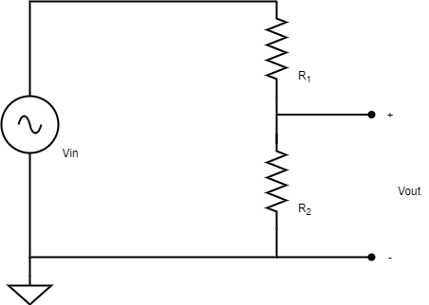

Figure Resistive voltage divider circuit.

The circuit has a frequency-independent transfer function, Vout/Vin, given as:

$\frac{V_{out}}{V_{in}}=\frac{R_{2}}{R_{1}+R_{2}}$ (Eq 1)

For equal values of R1 and R2, regardless of the actual value of resistance, the voltage transfer function always equals 0.5; the open-circuit (unloaded) output voltage is always ½ of the input voltage.

# Measuring various waveforms

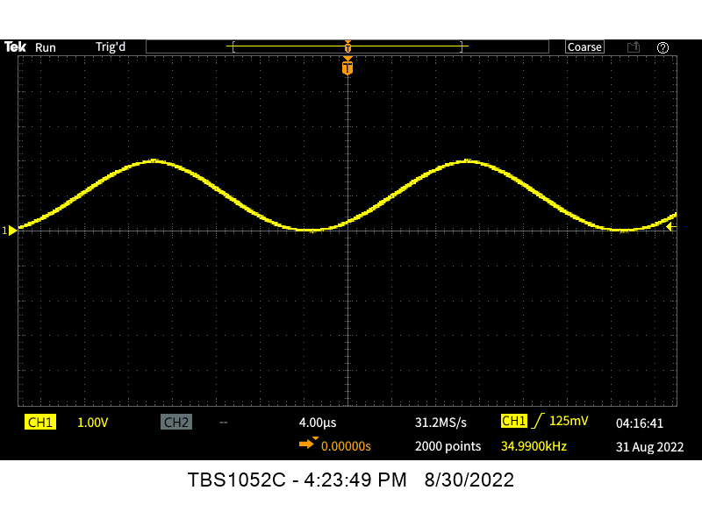The function generator was set to deliver several different waveforms and the oscilloscope controls were set to display the important features of these waveforms. The following figures illustrate the measurements that were made.

Figure . Oscilloscope screen showing function generator delivering a sine wave at 35 kHz, 2Vpp, with +1V dc offset.

Figure . Oscilloscope screen showing a pulse wave having pulse frequency of 10 kHz, low level 0 V, high level 4 V, pulse duty of 25%.

Figure . Oscilloscope screen showing a triangle wave having period of 200 μs, lowest voltage 0 V, highest voltage 4 V, ramp up time 75% of period, ramp-down time 25% of period.

# Comparing Oscilloscope and Multimeter measurements

The voltage divider was set up with two 1000 Ω resistors, then the function generator was set to produce an open-circuit voltage of 2 Vpp at 10 kHz. The oscilloscope was set to trigger on the rising edge of the channel 1 waveform at a trigger level of +0.5V to produce the waveform shown in Figure 5.

Figure . Waveform for which the voltage equation of time was computed.

The equation of this voltage waveform is:

$V\left(t\right)=sin⁡(t+0.251rads)$ Equation

After connecting the function generator to the input terminals of the voltage divider, the input and output voltages were measured on Ch 1 and Ch 2 respectively, of the oscilloscope. The results are shown in Figure 6.

Figure . Oscilloscope screen showing simultaneous measurement of the input and output voltages of the voltage divider circuit.

The rms values of the input and output voltages were then measured with the digital multimeter and found to agree with the readings from the oscilloscope that is, when the rms values were multiplied by $\sqrt{2}$ to compute the peak amplitude of the sine wave, that peak amplitude was equal to the value measured by the oscilloscope. For example, the DMM measurements of the Vin and Vout voltages were 0.660 Volts and 0.328 Volts respectively. Those values multiplied by $\sqrt{2}$ are 0.933 Volts and 0.464 Volts, which are both very close to their expected values (1 Volt and 0.5 Volts).

# Loading effect on Function Generator

In a final experiment, the resistive voltage divider was rebuilt using two 50 Ω resistors. When the function generator was reconnected, without changing the voltage amplitude knobs, both the input and output voltages were observed to be lower than in the previous measurement where the voltage divider was constructed from two 1000 Ω resistors. The reason for this is that when there is less resistance there is also less electric potential. This difference is so drastic due to the vast differences in total resistance present (100Ω vs 2000Ω).

# Conclusions

This project was very useful for introducing the basic controls of the three benchtop instruments. A significant finding is that the function generator does not act like an ideal voltage source, but instead it acts like a voltage source behind a 50 Ω resistance. This has a result that the voltage applied to a circuit will be slightly different, or maybe even significantly different, than open circuit voltage, so loading effects should always be considered.